Nagios Installaion Guide

Nagios is an Open Source monitoring tool, its provides you monitoring environment to always keep an eye on your all machines / networks .

With Nagios, you can monitor your remote hosts and their services remotely on a single window. It shows warnings and indicates if something goes wrong in your servers which eventually helps us to detect some problems before they occur. It helps us to reduce downtime and business losses.

# Installing Nagios 4.3.4 and Nagios Plugin 2.2.1

If you follow these instructions correctly, you will end up with following information.

* Nagios and its plugins will be installed under /usr/local/nagios directory.
* Nagios will be configured to monitor few services of your local machine (Disk Usage, CPU Load, Current Users, Total Processes, etc.)
* Nagios web interface will be available at <http://localhost/nagios>

## Step 1: Install Required Dependencies

We need to install Apache, PHP and some libraries like gcc, glibc, glibc-common and GD libraries and its development libraries before installing Nagios 4.3.4 with source. And to do so, we can use yum default package installer.

* [root@vikcee1920]# yum install -y httpd httpd-tools php gcc glibc glibc-common gd gd-devel make net-snmp

-------------- On Fedora 22+ Onwards --------------

* [root@vikcee1920]# dnf install -y httpd httpd-tools php gcc glibc glibc-common gd gd-devel make net-snmp
* [root@vikcee1920]# yum install wget
* [root@vikcee1920]# yum install unzip

## Step 2: Create Nagios User and Group

Create a new nagios user and nagcmd group account and set a password.

* [root@vikcee1920]# useradd nagios
* [root@vikcee1920]# groupadd nagcmd

Next, add both the nagios user and the apache user to the nagcmd group.

* [root@vikcee1920]# usermod -G nagcmd nagios
* [root@vikcee1920]# usermod -G nagcmd apache

## Step 3: Download Nagios Core 4.3.4 and Nagios Plugin 2.2.1

Create a directory for your Nagios installation and all its future downloads.

* [root@vikcee1920]# mkdir /root/nagios
* [root@vikcee1920]# cd /root/nagios

Now download latest Nagios Core 4.3.4 and Nagios plugins 2.2.1 packages with wget command.

* [root@vikcee1920 nagios~]# wget <https://assets.nagios.com/downloads/nagioscore/releases/nagios-4.3.4.tar.gz>
* [root@vikcee1920 nagios~]# wget <https://nagios-plugins.org/download/nagios-plugins-2.2.1.tar.gz>

## Step 4: Extract Nagios Core and its Plugins

We need to extract downloaded package with tar command as follows.

* [root@vikcee1920 nagios~]# tar -xvf nagios-4.3.4.tar.gz
* [root@vikcee1920 nagios~]# tar -xvf nagios-plugins-2.2.1.tar.gz

When you extract these tarballs with tar command, two new folders will appear in that directory.

nagios-4.3.4

nagios-4.3.4.tar.gz

nagios-plugins-2.2.1

nagios-plugins-2.2.1.tar.gz

### Configure Nagios Core

Now, first we will configure Nagios Core and to do so we need to go to Nagios directory and run configure file and if everything goes fine, it will show the output in the end as sample output. Please see below.

* [root@vikcee1920 nagios~]# cd nagios-4.3.4/
* [root@vikcee1920 nagios-4.3.4 ]# ./configure --with-command-group=nagcmd

### Sample Output:

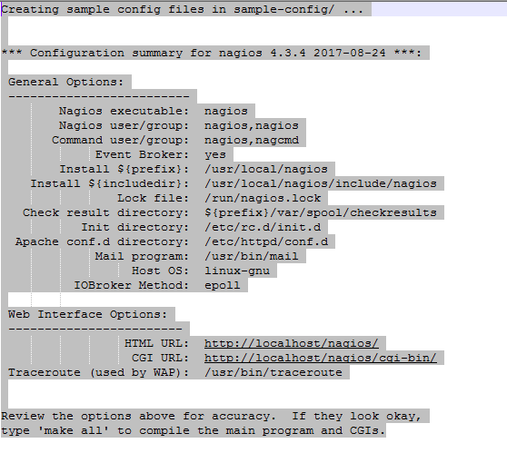

After configuring, we need to compile and install all the binaries with make all and make install command, it will install all the needed libraries in your machine and we can proceed further.

* [root@vikcee1920 nagios-4.3.4 ]# make all
* [root@vikcee1920 nagios-4.3.4 ]# make install

Sample output: 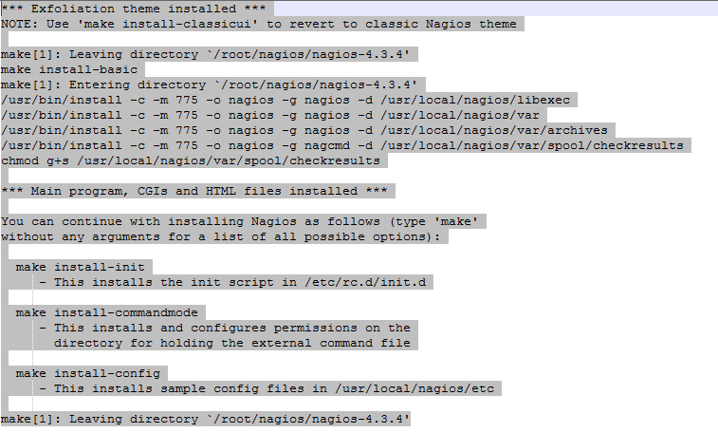

Following command will install the init scripts for Nagios.

* [root@vikcee1920 nagios-4.3.4 ]# make install-init

To make nagios work from command line we need to install command-mode.

* [root@vikcee1920 nagios-4.3.4 ]# make install-commandmode

Next, install sample nagios files, please run following command.

* [root@vikcee1920 nagios-4.3.4 ]# make install-config

Sample output: 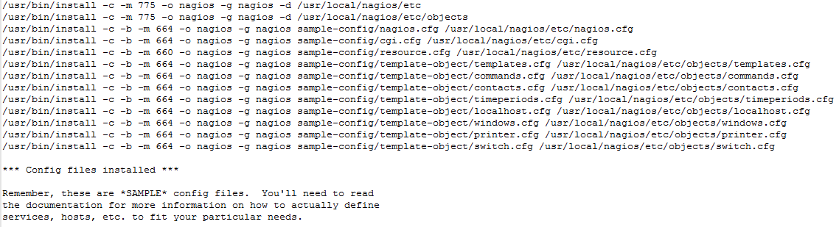

## Step 5: Install and Configure Web Interface for Nagios

We are done with all configuration in the backend, now we will configure Web Interface For Nagios with following command. The below command will Configure Web interface for Nagios and a web admin user will be created “nagiosadmin”.

* [root@vikcee1920 nagios-4.3.4 ]# make install-webconf

In this step, we will be creating a password for “nagiosadmin”. After executing this command, please provide a password twice and keep it remember because this password will be used when you login in the Nagios Web interface.

* [root@vikcee1920 nagios-4.3.4]# htpasswd -s -c /usr/local/nagios/etc/htpasswd.users nagiosadmin

New password:

Re-type new password:

Adding password for user nagiosadmin

Restart Apache to make the new settings take effect.

* [root@vikcee1920 ]# service httpd start [On RHEL/CentOS 6/5 and Fedora]
* [root@vikcee1920 ]# systemctl start httpd.service [On RHEL/CentOS 7 and Fedora 19 Onwards]

## Step 6: Compile and Install Nagios Plugin

We have downloaded nagios plugins in /root/nagios, Go there and configure and install it as directed below.

* [root@vikcee1920 nagios]# cd /root/nagios
* [root@vikcee1920 nagios]# cd nagios-plugins-2.2.1/
* [root@vikcee1920 nagios]# ./configure --with-nagios-user=nagios --with-nagios-group=nagios
* [root@vikcee1920 nagios]# make
* [root@vikcee1920 nagios]# make install

## Step 7: Verify Nagios Configuration Files

Now we are all done with Nagios configuration and its time to verify it and to do so please insert following command. If everything goes smooth it will show up similar to below output.

* [root@vikcee1920 nagios]# /usr/local/nagios/bin/nagios -v /usr/local/nagios/etc/nagios.cfg

### Sample Output

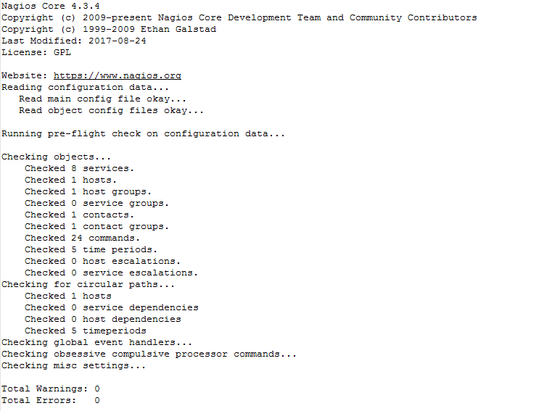

Things look okay - No serious problems were detected during the pre-flight check

## Step 8: Add Nagios Services to System Startup

To make Nagios work across reboots, we need to add nagios and httpd with chkconfig and systemctl command.

### On RHEL/CentOS 6/5 and Fedora

* [root@vikcee1920 ]# chkconfig --add nagios
* [root@vikcee1920 ]# chkconfig --level 35 nagios on
* [root@vikcee1920 ]# chkconfig --add httpd
* [root@vikcee1920 ]# chkconfig --level 35 httpd on

### On RHEL/CentOS 7 and Fedora 19-26

* [root@vikcee1920 ]# systemctl enable nagios
* [root@vikcee1920 ]# systemctl enable httpd

### Restart Nagios to make the new settings take effect.

* [root@vikcee1920 ]# service nagios start [On RHEL/CentOS 6/5 and Fedora]
* [root@vikcee1920 ]# systemctl start nagios.service [On RHEL/CentOS 7 and Fedora 19-24]

## Step 9: Login to the Nagios Web Interface

Your nagios is ready to work, please open it in your browser with “http://Your-server-IP-address/nagios” or “http://FQDN/nagios” and Provide the username “nagiosadmin” and password.

Nagios Web Dashboard

